Experiment – 1

ER DIAGRAM OF COLLEGE DATABASE

**Aim:** Draw an ER diagram of a college database.

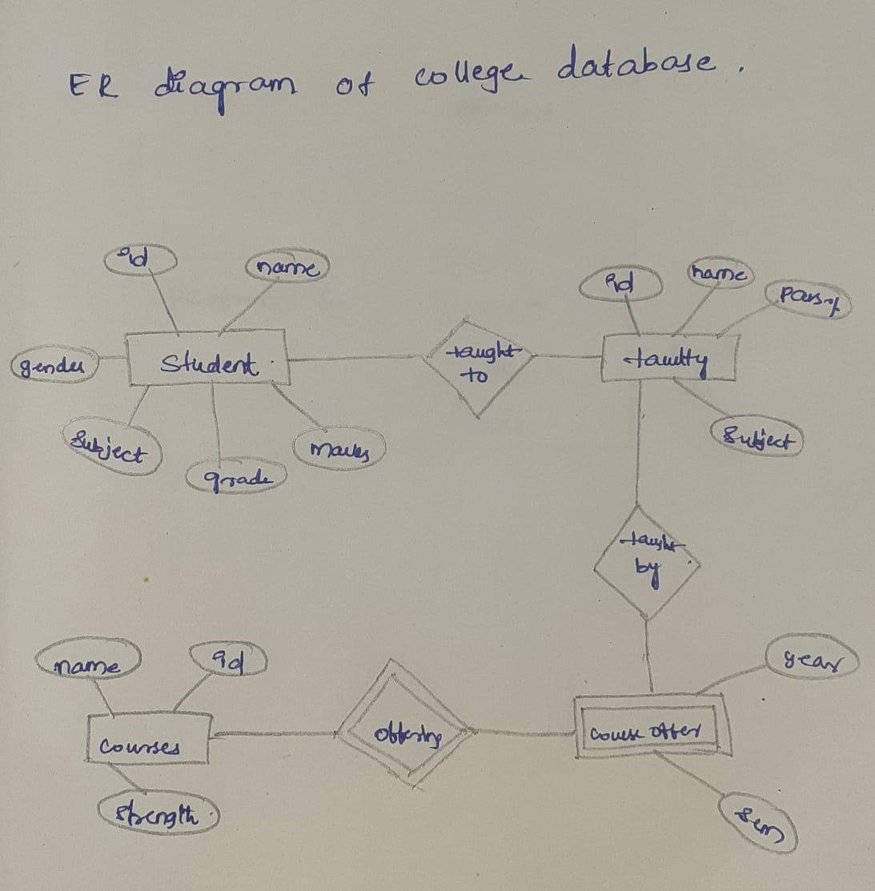

Experiment – 2

ER DIAGRAM FOR SAILOR BOAT DATABASE

**Aim**: Draw an ER diagram of sailors database.

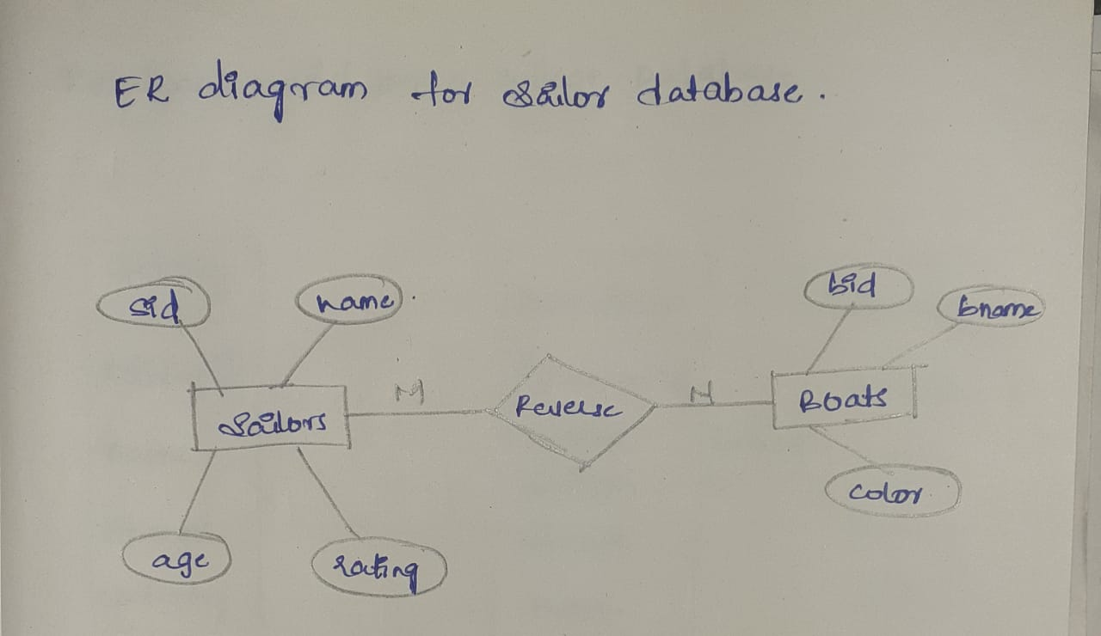

Experiment-3

RELATIONAL MODEL FOR A COLLEGE DATABASE

**Aim**: Draw a relational model for a college database

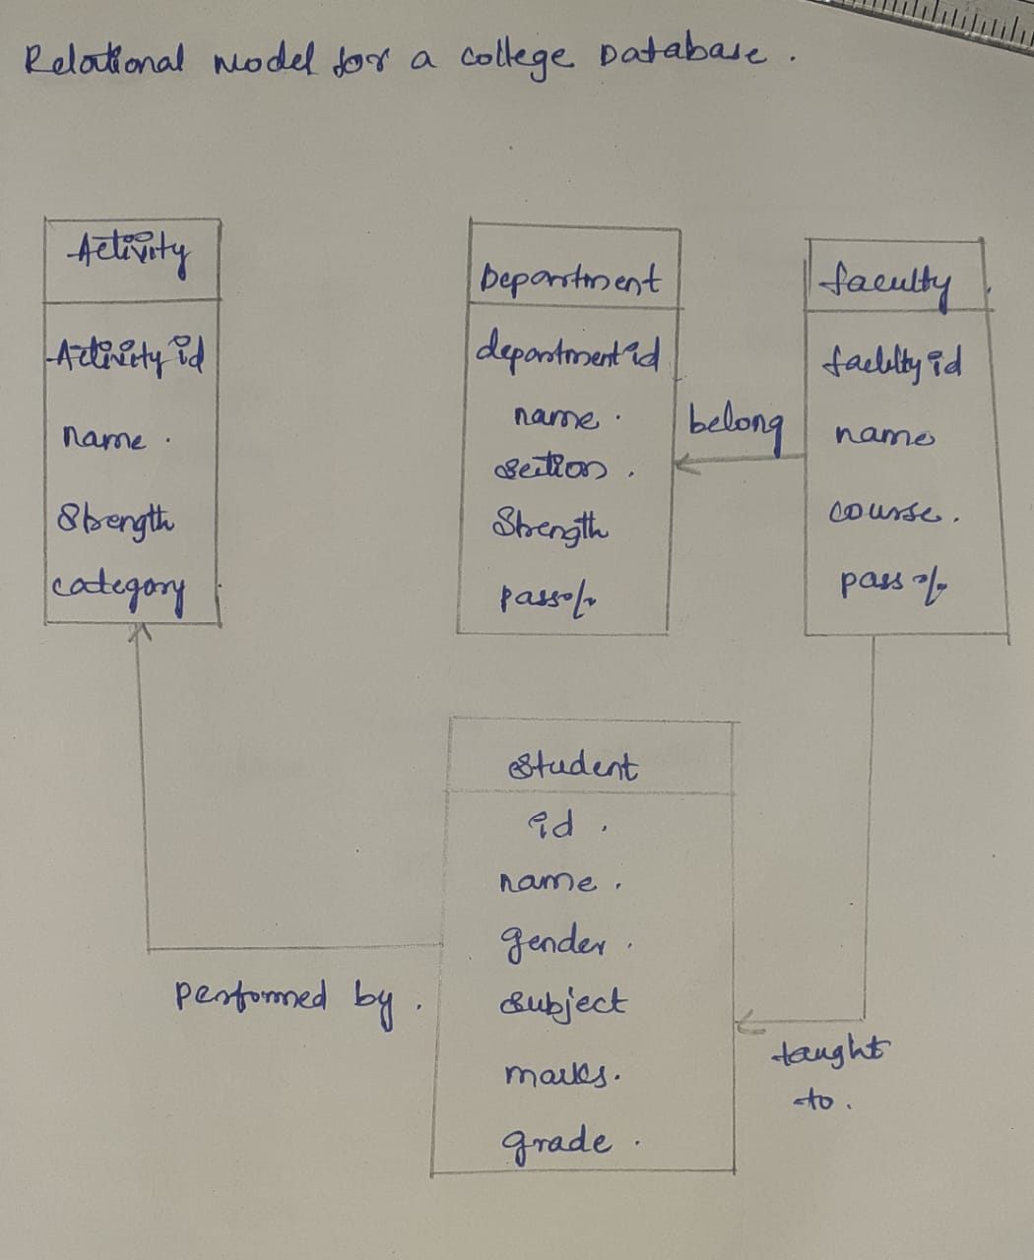

Experiment-4

RELATIONAL MODEL FOR SAILOR BOAT DATABASE

**Aim:** Draw a relational model for sailors database

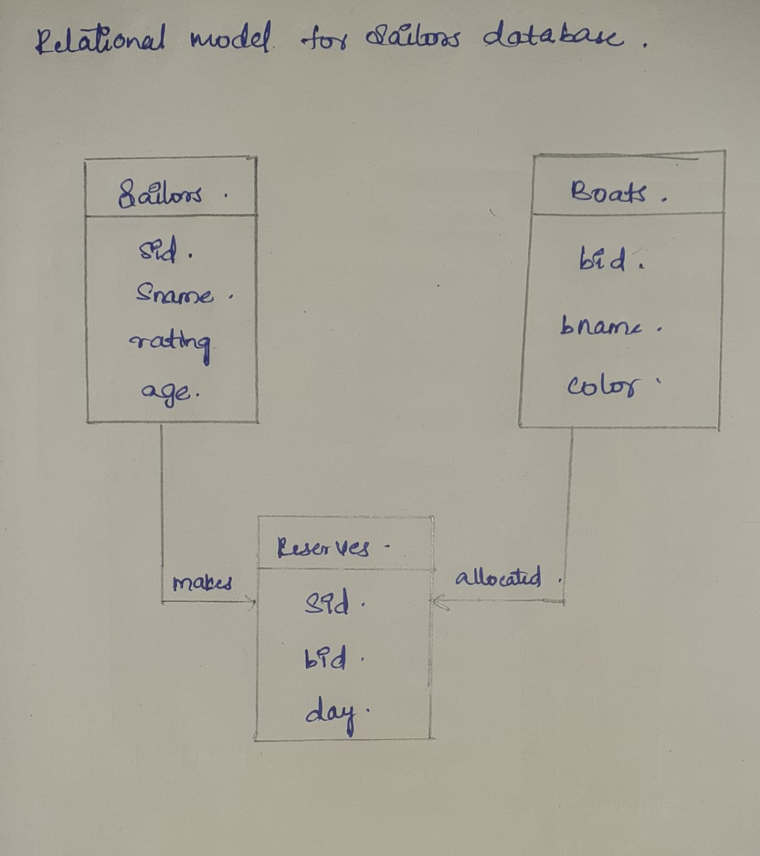

Experiment-5

1.Create schema college



2.Create table-student and attributes are studid,studname,gender,subject,marks,grade

3.Create table-Faculty and attributes are fac_id,fac_name,course,pass percentage

4.Create table-department and attributes are dept_no,dept_name,section,no of students,pass percentage

5.Create table-Activity and attributes are act_id,act_name,no of students opted ,category of activity

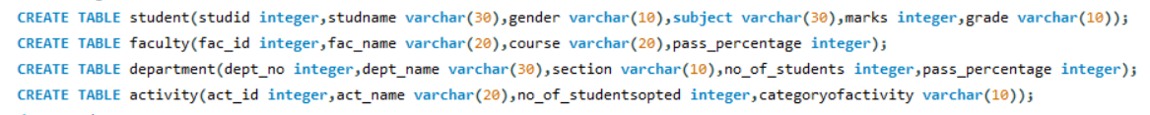

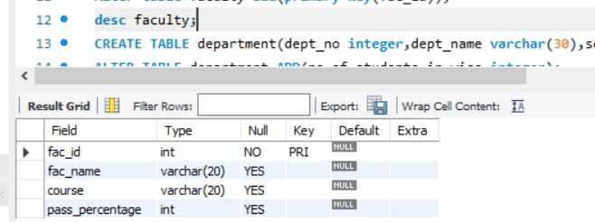

Student table:

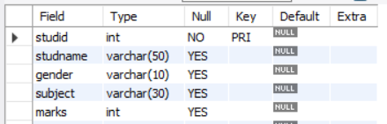

1.Add address in student table,change the datatype size for student name and make studid as primary key

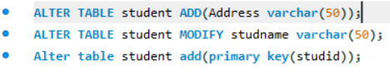

2.Add faculty total mentor details,make fac_id as primary key



3.Add no of students in wise and make dept no as primary key



4.Add faculty name and change the size of act_name and act_id as primary key

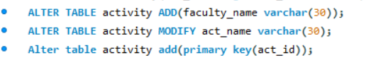

Experiment-6

1.Insert 5 instances in each table and display the result

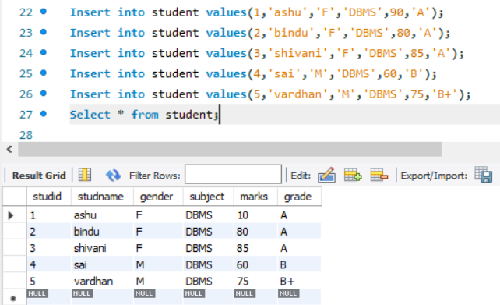

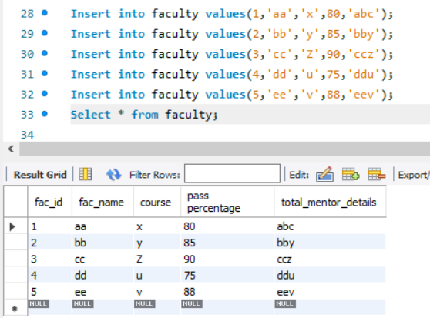

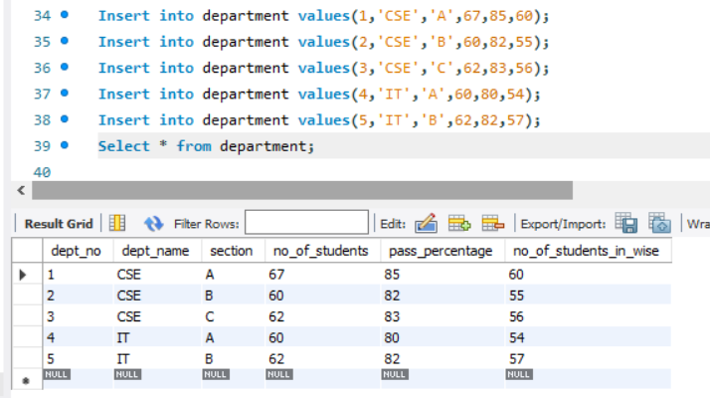

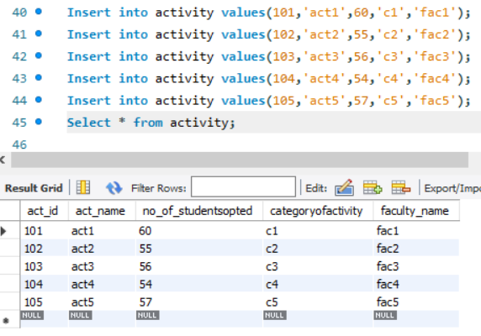

2.Display student no,marks from student table

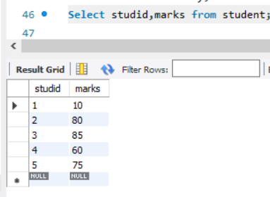

3.Display faculty no,name from faculty table

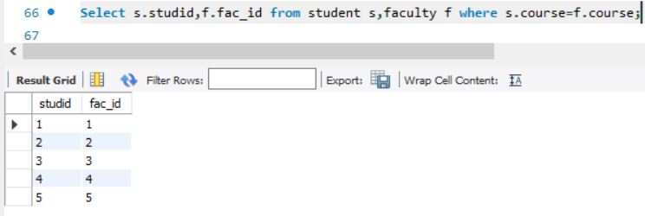

Experiment-7

1.Display 1 to 5 students details

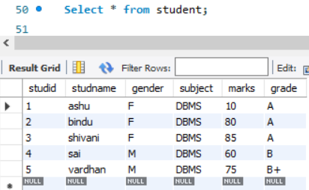

2.Display who got grade A

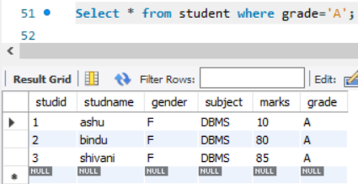

3.Display whose mark is less than 50

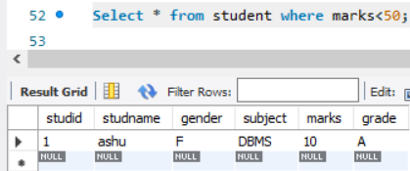

4.Display student id and name

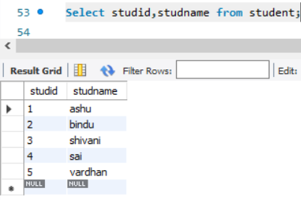

5.Display the student id and name whose mark is 50 to 60 and female

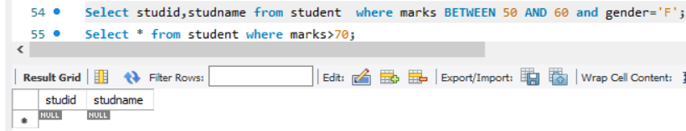

6.Display the list of students who gets greater than 70

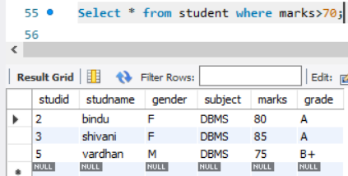

7.delete the failure students

Display complete table

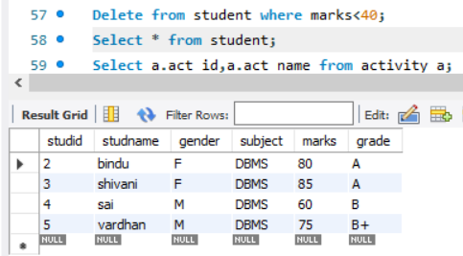

8.display activity id,name using object

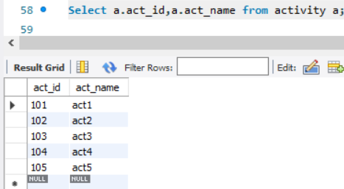

9.Add course to student table then insert values.display student id,faculty id using course name condition with object

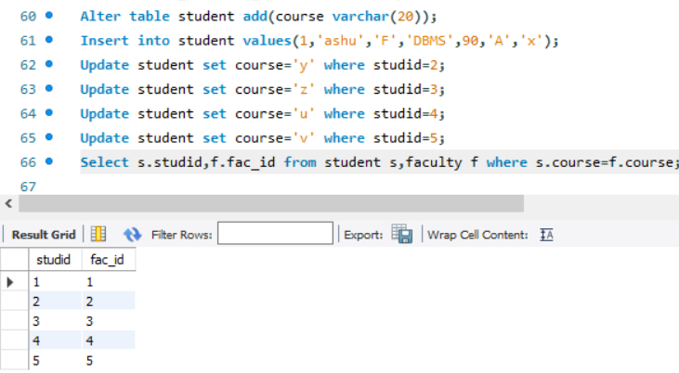

Activity-5

1.change mark to 50 whose id is 4



2.change name whose id is 3



3.change activity name whose id between 5 to 7

4.change department section to A whose id is less than 5



5.delete row who has id=3



6.select student name and activity name from student and activity table

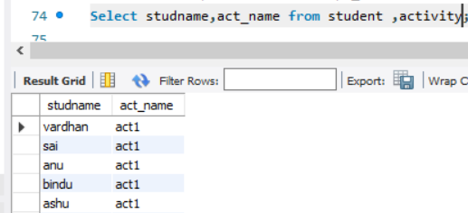

7.Select student name and mark from student and faculty name from faculty

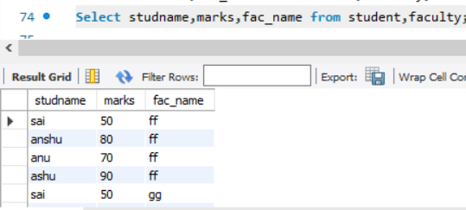

Activity-6

1.select department starts from ‘c’and faculty name ends with ‘’

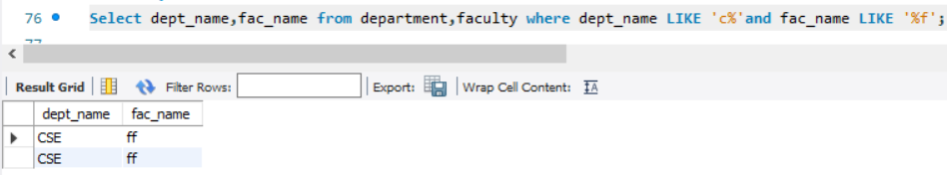

2.select activity having character between ‘ck’

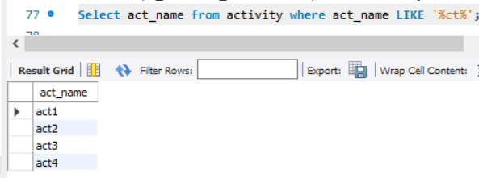

3.display students list descending order of student id

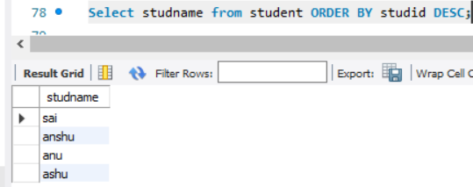

4.display faculty name ascending order

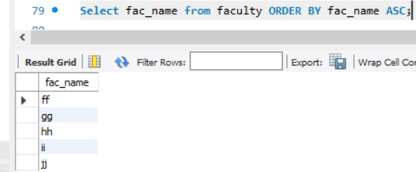

5.display students list based on grade

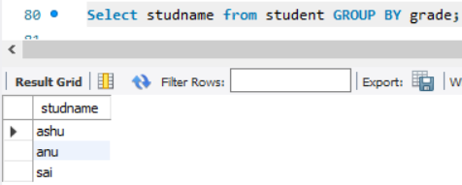

6.display students having grade a using group by

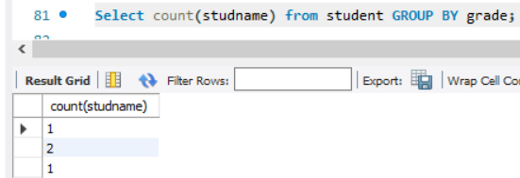

7.group by faculty id and display

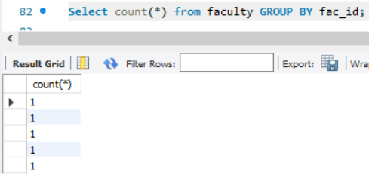

8.display the students list whose grade is A using having

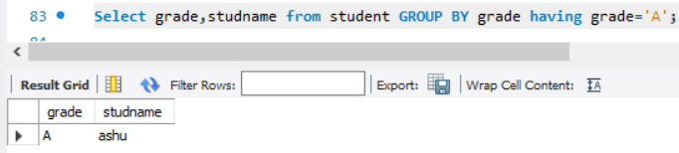

9.display the faculty list who are teaching subject pps

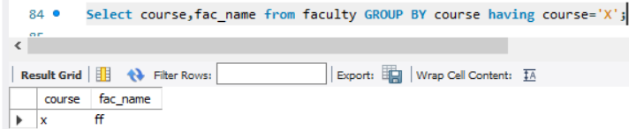

10.Apply aggregate functions in students marks-min,max,sum,count,avg

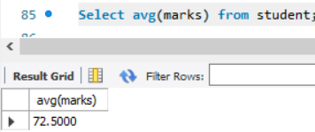

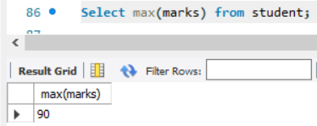

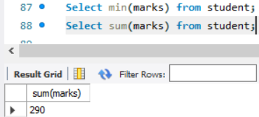

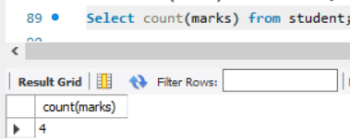

Experiment-9

Views

1.Create a table student with attributes studno,name,dept

2.display



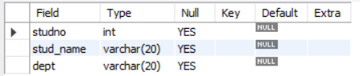

3.Create view and select



4.insert values

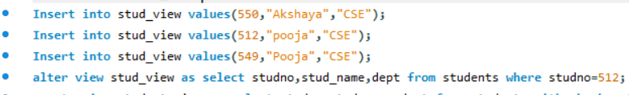

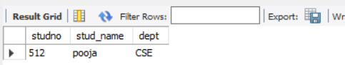

5.Create view with check option

Insert values and alter table

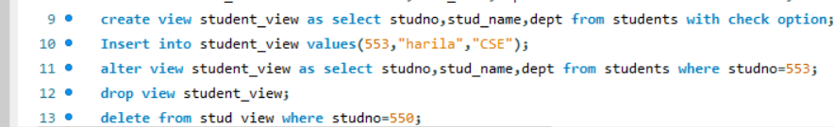

Experiment-10

Triggers

1. Create a table with attribute sname, and another table with newname



2.Create a trigger to insert into second table before inserting in first table.

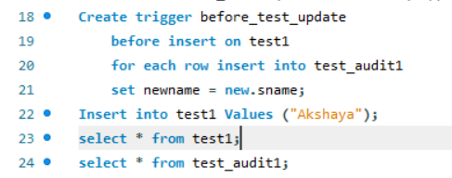

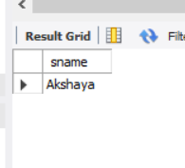

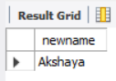

1. Create a table for account details with attributes account number and an amount.

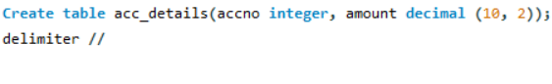

3.Create a trigger to check if amount is negative or greater than zero before inserting to table.

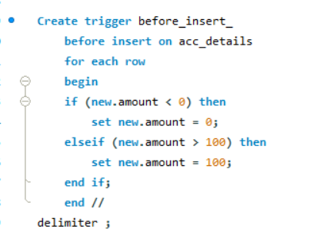

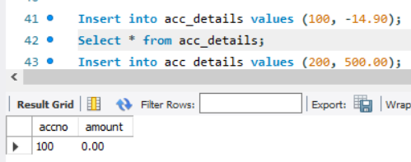

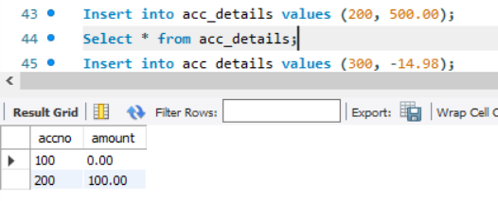

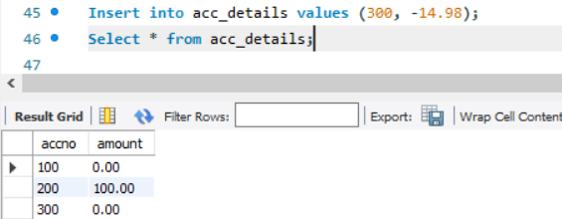

Experiment-11

Procedures

* Create a table with attributes students and marks
* Insert values into the table.

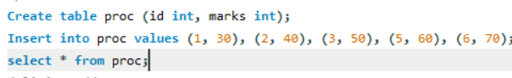

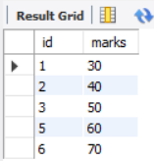

* Create a procedure to get the merit students (marks > 50).
* Create a procedure to get marks of a given id (using in).

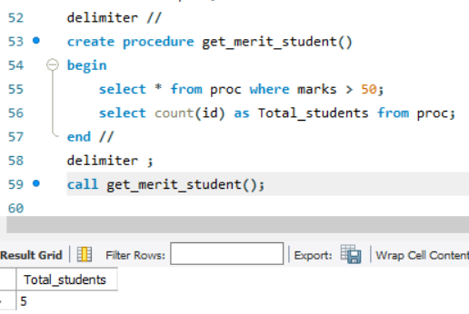

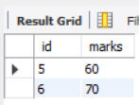

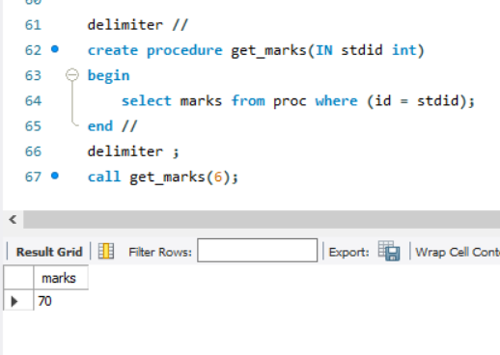

Experiment-12

Cursors

* Create a table with attributes students and marks.
* Insert values into the table.

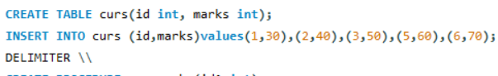

* Create a procedure, and fetch the marks of given id using a cursor.

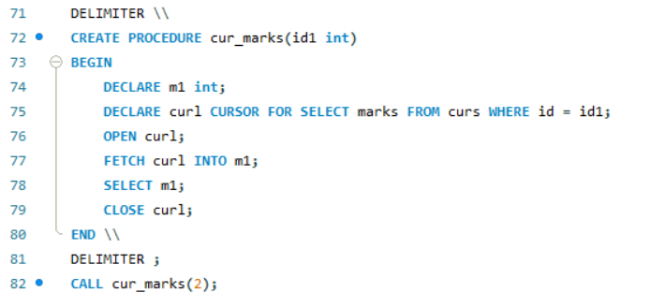

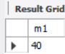

Create a procedure, and fetch the highest marks using a cursor

